**REST - Country Web Serice**

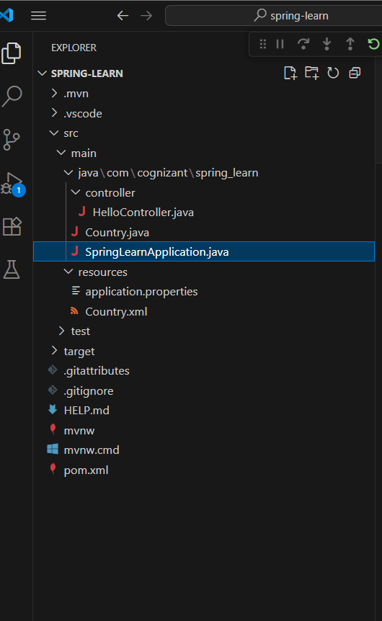

HelloController.java

package com.cognizant.spring_learn.controller;

import org.springframework.context.ApplicationContext;

import org.springframework.context.support.ClassPathXmlApplicationContext;

import org.springframework.web.bind.annotation.GetMapping;

import org.springframework.web.bind.annotation.RestController;

import com.cognizant.spring_learn.Country;

@RestController

public class HelloController {

    ApplicationContext context = new ClassPathXmlApplicationContext("Country.xml");

    @GetMapping("/country")

    public Country getCountryIndia(){

            Country country = context.getBean("country", Country.class);

            return country;

        }

}

Country.xml

<?xml version="1.0" encoding="UTF-8"?>

<beans xmlns="http://www.springframework.org/schema/beans"

       xmlns:xsi="http://www.w3.org/2001/XMLSchema-instance"

       xsi:schemaLocation="http://www.springframework.org/schema/beans

       http://www.springframework.org/schema/beans/spring-beans.xsd">

    <bean id="country" class="com.cognizant.spring_learn.Country">

        <property name="code" value="IN"/>

        <property name="name" value="India"/>

    </bean>

</beans>

Output

